8-47

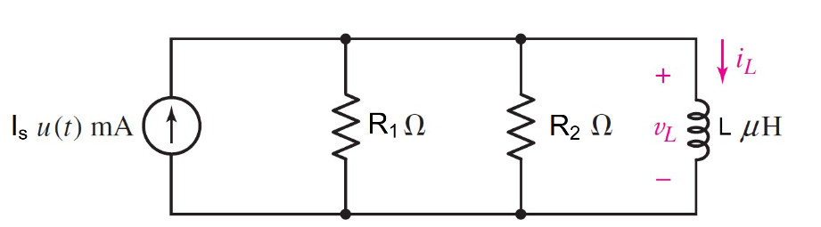

**Given**

R1= 25Ω, R2= 100Ω, L = 3 µH,

Is = 2 *u(t)* mA

**Find**

At t<0

1. iL(0-)= 0 ,vL(0-)=0

At t>0 t=∞

1. iL(∞)= 0.002 A

At t>0 t=0+

1. iL(0+)= 0 ,vL(0+)=0.04
2. τ = 0.15 µs
3. iL(t) = 0.002 -0.002*exp^(-t/ 0.15µ)

**Random variables**

R1 = {5:30}

R2 = {100:500:50}

L = {1e-3:3e-3:1e-3}

Is = {1:5}

**Global variables**

#t<0 t=0-

Is(0-) = 0

iL(0-) = 0

vL(0-)= 0

#t>0 t=∞

Is(0+) = 0.002

iL(∞)= Is(0+)

# t≥0 t=0+

iL(0+)= iL(0-)

iR2 = (R1/(R1+R2)*Is(0+)

vL(0+) = R2* iR2

Req = R1*R2/(R1+R2

τ =L/ Req

iL(t) = iL(∞)+(iL(0+)-iL(∞))*exp^(-t/ τ)

**Answer**

1. iL(0-)= 0 ,vL(0-)=0
2. iL(∞)= 0.002 A
3. iL(0+)= 0 ,vL(0+)=0.04
4. τ = 0.15 µs
5. iL(t) = 0.002 -0.002*exp^(-t/ 0.15µ)

**Ex.**

Given R1= 25Ω, R2= 100Ω, L = 3 µH,

Is = 2 *u(t)* mA

#t<0

Is(0-) = 0

iL(0-) = **0 A**

vL(0-)= **0 V**

#t>0 t=∞

Is(0+) = 0.002 A

iL(∞)= Is(0+) = **0.002 A**

#t≥0 t=0+

iL(0+) = iL(0-) = **0A**

iR2 = (25/(25+100)*0.002 = 0.4 mA

vL(0+) = 100* 0.0004 = **0.04 V**

Req=20 Ω

τ =3x10-6/20 = **0.15x10-6 s**

iL(t) = iL(∞)+(iL(0+)-iL(∞))*exp^(-t/ τ)

iL(t) = 0.002 +(0-0.002 )*exp^(-t/0.15x10-6)

iL(t) = **0.002 -0.002*exp^(-t/0.15x10-6) A**

8-48

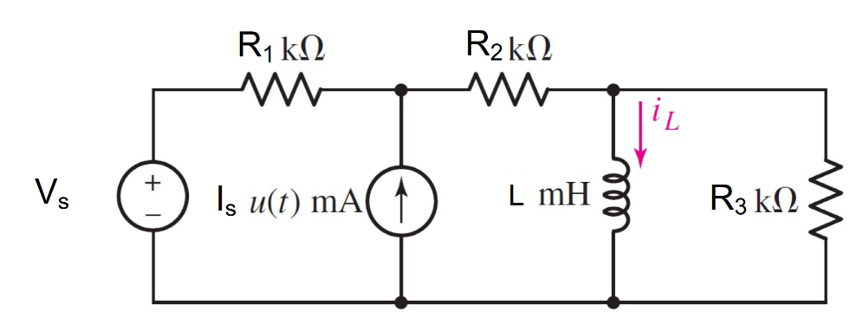

**Given**

R1= 2kΩ, R2= 1kΩ, R2= 1kΩ, L = 10 mH,

Is = 50 *u(t)* mA, Vs = 1.2 V

**Find**

At t<0

1. iL(0-)= 0.0004 A

At t>0 t=∞

1. iL(∞)= 0.03373 A

At t>0 t=0+

1. τ = 1.333 µs
2. iL(t)

= 0.03373 -0.03333*exp^(-t/1.333µ)

**Random variables**

R1 = {5:30}

R2 = {100:500:50}

L = {1e-3:3e-3:1e-3}

Is = {1:5}

**Global variables**

#t<0 t=0-

Is(0-) = 0

iL(0-) = Vs/( R1+R2)

#t>0 t=∞

Is(0+) = 0.05

v= R2* (Vs + (R1* Is(0+)))/(R1+R2)

iL(∞)= v/R2

# t≥0 t=0+

iL(0+)= iL(0-)

Req = (R1+R2)*R3/(R1+R2+R3)

τ =L/ Req

iL(t) = iL(∞)+(iL(0+)-iL(∞))*exp^(-t/ τ)

**Answer**

1. iL(0-)= 0.0004 A
2. iL(∞)= 0.03373 A
3. τ = 1.333 µs
4. iL(t)

= 0.03373 -0.03333*exp^(-t/1.333µ)

**Ex.**

R1= 2kΩ, R2= 1kΩ, R2= 1kΩ, L = 10 mH,

Is = 50 *u(t)* mA, Vs = 1.2 V

#t<0

Is(0-) = 0

iL(0-) = 1.2/(2000+1000) = **0.4mA**

#t>0 t=∞

Is(0+) = 0.05

v= 1000* (1.2 + (2000*0.05))/(2000+1000)

=33.37 v

iL(∞)= 33.37/1000 = **0.03373 A**

#t≥0 t=0+

iL(0+) = iL(0-) = 0.4mA

Req=750 Ω

τ =10x10-3/750 = **1.333x10-6 s**

iL(t) = iL(∞)+(iL(0+)-iL(∞))*exp^(-t/ τ)

iL(t) = 0.003373 +(0.03373-0.0004 )*exp^(-t/1.333x10-6)

iL(t)

= **0.03373 -0.03333*exp^(-t/1.333x10-6) A**

8-49

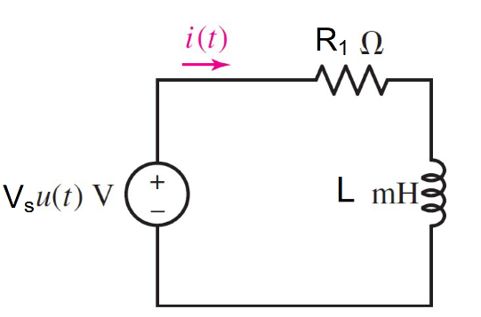

**Given**

R1= 20Ω, L = 45mH, Vs = 2 *u(t)*V

**Find**

At t<0

1. i(0-)= 0

At t>0 t=∞

1. i(∞)= 0.1 A

At t>0 t=0+

1. τ = 2.25 ms
2. i(t)

= 0.1 -0.1*exp^(-t/0.00225)

**Random variables**

R1 = {5:30}

L = {1e-3:50e-3:1e-3}

Vs = {1:5}

**Global variables**

#t<0 t=0-

Vs(0-) = 0

i(0-) = 0

#t>0 t=∞

Vs(0+) = 2

i(∞)= Vs(0+) /R1

# t≥0 t=0+

i(0+)= i(0-)

Req = R1

τ =L/ Req

i(t) = iL(∞)+(iL(0+)-iL(∞))*exp^(-t/ τ)

**Answer**

1. i (0-)= 0 A
2. i(∞)= 0.1 A
3. τ = 2.25 ms
4. i(t)

= 0.1 -0.1*exp^(-t/0.00225)

**Ex.**

R1= 20Ω, L = 45mH, Vs = 2 *u(t)*V

#t<0

Vs(0-) = 0

i(0-) = **0 A**

#t>0 t=∞

Vs(0+) = 2 V

i(∞)= 2/20 = **0.1 A**

#t≥0 t=0+

i(0+) = i(0-) = 0A

Req=20 Ω

τ =45x10-3/20 = **0.00225 s**

i(t) = i(∞)+(i(0+)-i(∞))*exp^(-t/ τ)

i(t) = 0.1 +(0-0.1 )*exp^(-t/0.00225)

i(t) = **0.1 -0.1*exp^(-t/0.00225) A**

8-50

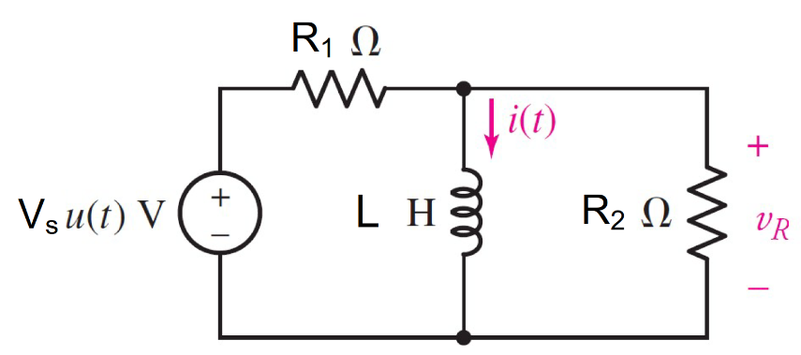

**Given**

R1= 30Ω, R2= 5Ω,L = 5H, Vs = 12 *u(t)*V

**Find**

At t>0 t=∞

1. i(∞)= 0.4 A

At t>0 t=0+

1. τ = 1.1667s
2. i(t) = 0.4 -0.4*exp^(-t/1.1667)
3. VR(0+) =1.7142 V

**Random variables**

R1 = {5:30}

R2 = {5:30}

L = {1:5}

Vs = {1:15}

**Global variables**

#t<0 t=0-

VS(0-) = 0

VR(0-) = 0

i(0-) = 0

#t>0 t=∞

Vs(0+) = 12

i(∞)= Vs(0+) /R1

# t≥0 t=0+

i(0+)= i(0-)

iR2= Vs(0+)/(R1+R2)

VR(0+)= iR2/R2

Req = R1*R2/(R1+R2)

τ = L/ Req

i(t) = i(∞)+(i(0+)-i(∞))*exp^(-t/ τ)

**Answer**

1. i(∞)= 0.4 A
2. τ = 1.1667s
3. L(t) = 0.4 -0.4*exp^(-t/1.1667)
4. VR(0+) =1.7142 V

**Ex.**

R1= 30Ω, R2= 5Ω,L = 5H, Vs = 12 *u(t)*V

#t<0

VS(0-) = 0

VR(0-) = 0

i(0-) = 0

#t>0 t=∞

Vs(0+) = 12 V

i(∞)= 12/30 = **0.4 A**

#t≥0 t=0+

i(0+) = i(0-) = 0A

iR2= 12/(30+5)

VR(0+)= 12/7=**1.7142 V**

τ =5*(150/35) = **1.1667 s**

i(t) = i(∞)+(i(0+)-i(∞))*exp^(-t/ τ)

i(t) = 0.4 +(0-0.4 )*exp^(-t/1.1667)

i(t) = **0.1 -0.4*exp^(-t/1.1667) A**

8-51

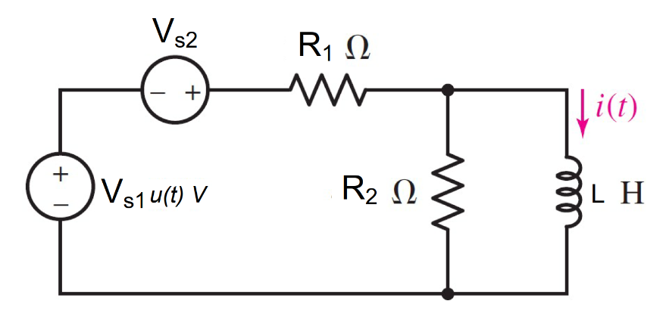

**Given**

R1= 100Ω, R2= 400Ω,L = 5H, Vs1 = 6 *u(t)*V

Vs2 = 5 V

**Find**

At t<0

1. i(0-)= 0.05 A

At t>0 t=∞

1. i(∞)= 0.11 A

At t>0 t=0+

1. τ = 0.625 s
2. i(t) = 0.11 -0.0.6*exp^(-16t) A

**Random variables**

R1 = {100:1000:100}

R2 = {100:1000:100}

L = {1:5}

Vs1 = {1:15}

Vs1 = {1:15}

**Global variables**

#t<0 t=0-

Vs1 (0-) = 0

i(0-) = Vs2/ R1

#t>0 t=∞

Vs1(0+) = 6

i(∞)= Vs1(0+)+ Vs2 /R1

# t≥0 t=0+

i(0+)= i(0-)

Req = R1*R2/(R1+R2)

τ = L/ Req

i(t) = i(∞)+(i(0+)-i(∞))*exp^(-t/ τ)

**Answer**

1. i(0-)= 0.05 A
2. i(∞)= 0.11 A
3. τ = 0.625s
4. i(t) = 0.11 -0.0.6*exp^(-16t)A

**Ex.**

R1= 100Ω, R2= 400Ω,L = 5H, Vs1 = 6 *u(t)*V

Vs2 = 5 V

#t<0

Vs1 (0-) = 0

i(0-) = Vs2/ R1 = 5/100 = **0.05A**

#t>0 t=∞

Vs1(0+) = 6

i(∞)= 6+ 5 /100 = **0.11A**

#t≥0 t=0+

i(0+) = i(0-) = 0.05A

τ =5*(80) = **0.625 s**

iL(t) = iL(∞)+(iL(0+)-iL(∞))*exp^(-t/ τ)

iL(t) = 0.11 +(0.05-0.11 )*exp^(-16t)

iL(t) = **0.11 -0.06*exp^(-16t) A**